Link in List

# Program 1:

<html>

  <head>

    <title>work14</title>

  </head>

  <body>

    <ul type="square">

      <li>

        <a href="linkElements/work15.html"> WHEAT </a>

      </li>

      <li>

        <a href="linkElements/work16.html"> RICE </a>

      </li>

      <li>

        <a href="linkElements/work17.html"> MILK </a>

      </li>

      <li>

        <a href="linkElements/work18.html"> CURD </a>

      </li>

    </ul>

  </body>

</html>

# OutPut :

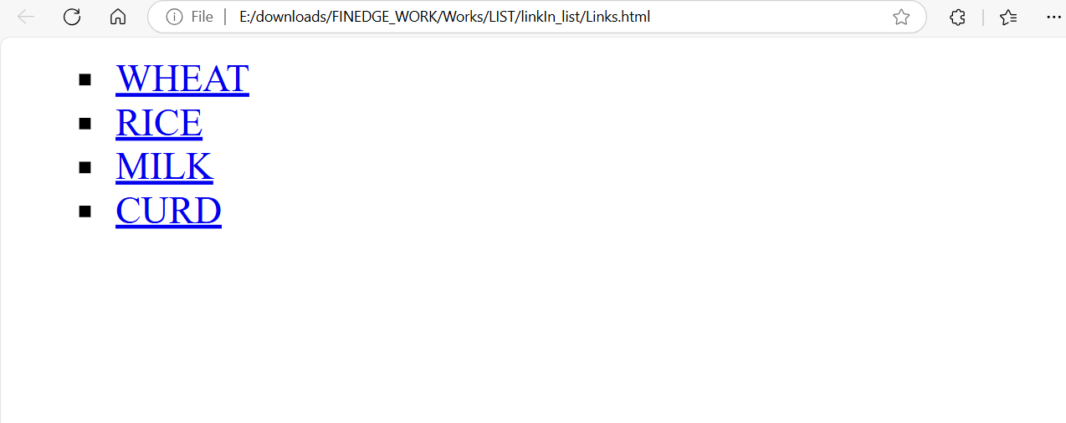

# Program 2:

<html>

<head>

    <title>work19</title>

</head>

<body>

    <a href="work20.html"><img src="C:\Users\user\Desktop\FINEDGE_WORK\INTERNAL_LINKING\icons8-angular-48.png" height="250" width="250"></a>

    <a href="work21.html"><img src="https://encrypted-tbn0.gstatic.com/images?q=tbn:ANd9GcT7Isxe4pqMxfjPccOdKRM3-zdiQ8oZc07Ypw&s" height="250" width="250"></a>

    <a href="work22.html"><img src="C:\Users\user\Desktop\FINEDGE_WORK\INTERNAL_LINKING\icons8-php-64.png" height="250" width="250"></a>

</body>

</html>

# OutPut :

